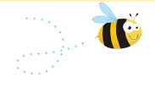
Parents’ Guide to the
Early Years Foundation Stage Framework 2021

What is the Early Years Foundation Stage?
Welcome to the Early Years Foundation Stage (EYFS), which is how the Government and early years professionals describe the time in your child’s life between birth and age 5.
This is a very important stage as it helps your child get ready for school as well as preparing them for their future learning and successes. From when your child is born up until the age of 5, their early years experience should be happy, active, exciting, fun and secure; and support their development, care and learning needs.

What is the EYFS Framework – why do we have one?
The EYFS Framework exists to support all professionals working in the EYFS to help your child, and was developed with a number of early years experts and parents.
The EYFS Framework was updated in 2021 to make it clearer and easier to use, with more focus on the things that matter most.
It sets out:
- The legal welfare requirements that everyone registered to look after children must follow to keep your child safe and promote their welfare
- The 7 areas of learning and development which guide professionals’ engagement with your child’s play and activities as they learn new skills and knowledge
- Assessments that will tell you about your child’s progress through the EYFS
- Expected levels that your child should reach at age 5, usually the end of the reception year; these expectations are called the “Early Learning Goals (ELGs)”
There is also guidance for the professionals supporting your child on planning the learning activities, and observing and assessing what and how your child is learning and developing.

How my child will be learning
The EYFS Framework explains how and what your child will be learning to support their healthy development.
Within the first 6 weeks of your child starting school, they will undertake the Reception Baseline Assessment (RBA). This is a short, task- based assessment of your child’s early literacy, communication, language and mathematics skills, carried out by a trusted, known adult.This will be done in a very informal way, it is to help staff plan future learning.
Your child will be learning skills, acquiring new knowledge and demonstrating their understanding through 7 areas of learning and development.
Children should mostly develop the 3 prime areas first. These are:
- Communication and language;
- Physical development; and
- Personal, social and emotional development.
These prime areas are those most essential for your child’s healthy development and future learning.
As children grow, the prime areas will help them to develop skills in 4 specific areas. These are:
- Literacy;
- Mathematics;
- Understanding the world; and
- Expressive arts and design.
These 7 areas are used to plan your child’s learning and activities. The professionals teaching and supporting your child will make sure that the activities are suited to your child’s unique needs. This is a little bit like a curriculum in primary and secondary schools, but it's suitable for very young children, and it's designed to be really flexible so that staff can follow your child's unique needs and interests.
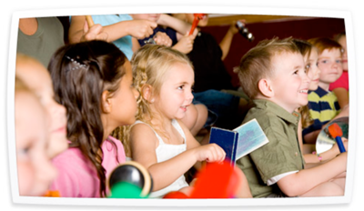
Children in the EYFS learn by playing and exploring, being active, and through creative and critical thinking which takes place both indoors and outside.

When your child is 5
At the end of the EYFS – in the summer term of the reception year in school – teachers complete an assessment which is known as the EYFS Profile. This assessment is carried out by the reception teacher and is based on what they, and other staff caring for your child, have observed over a period of time.

Another important part of the EYFS Profile is your knowledge about your child’s learning and development, so do let your child’s class teacher know about what your child does with you: such as how confident your child is in writing their name, reading and talking about a favourite book, speaking to people your child is not so familiar with or their understanding of numbers.
All of the information collected is used to assess how your child is doing in the 7 areas of learning and development. Finding out at this stage how your child is doing will mean that the teacher your child has in their next school year – year 1 – will know what your child really enjoys doing and does well, as well as helping them decide if your child needs a bit of extra support, what that support should be and if they are already getting it.
The school will give you a report of your child’s progress, including information from his or her EYFS Profile.

Where can I go for further information?
The most important place to find out more is your child’s school – do ask as many questions as you need to. We really do welcome speaking with you.

