Personal, Social, and Emotional Development

During my first year at school I will be developing my confidence and self-esteem, my ability to be assertive and stand up for my own rights or ask for adult support. I will be learning about relationships with both adults and children, making particular friendships and learning to share, to take turns and to negotiate with others. I will begin to understand rules, to empathise with others and to learn about differences I may see in cultures, religion or language.

I will develop the ability to express my feelings, to control them where appropriate and to express any anxieties to others. I will develop my independence in looking after myself and my things, choosing what I would like to do, finding what I need, planning my time, thinking of and acting on my own ideas and asking for help if I need it.

I will be able to take responsibility for tidying up, helping younger children, taking messages and carrying out a task. I will learn to be pleased with and be proud of what I can do.

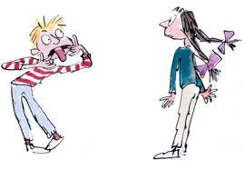
Communication and Language

I will be able to talk about what I want and how I feel and will have opportunities to express this through role play. I will be able to enjoy stories, poems, songs and rhymes, and will develop the ability to use language to describe past and present experiences and a sequence of events. I will develop my ability to question experiences and events and supply logical explanations or predict what might happen next.

I will have the chance to talk imaginatively and retell stories in my own words. I will learn to speak to others in small and large groups and share my ideas and thoughts with them. I will learn to listen to others and ask interesting and appropriate questions.

I will learn to follow a set of instructions and be able to answer ‘how’ and ‘why’ questions about my experiences.

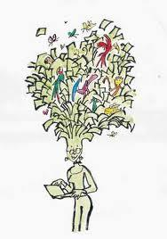
Physical Development

There will be lots of time for me to play and learn inside and outside the school. I will get the chance to become good at moving, climbing, controlling and coordinating as I play. I will have fun with my friends and teachers learning to use my body, my feet and my hands with more and more skill. I will get to use lots of outdoor toys to ride on, throw, catch, climb on and build with. I will be able to chase, race, jump, balance, play on my own and begin to play with a partner or a group or team.

When I am busy and active I will be able to feel the changes that take place in my body. I will be able to find out and talk about what helps to keep me fit and healthy and what food is good for me. I will learn to get my coat on or fasten my shoes so that I can look after myself.

I will use lots of tools for drawing, painting, cutting, woodwork, sewing, cooking, joining and dismantling as well as other equipment for building, threading, dressing dolls, creating tents, dens and structures and playing sport.

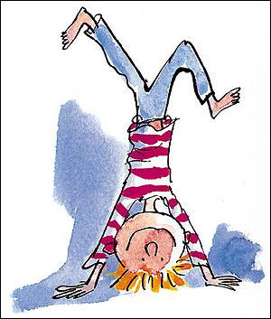
Literacy

Through handling books and sharing them with others, I will recognise that words tell stories and that the words I see in the world around me tell people something.

I will get the chance to see letters and words written down and to try and write them myself and use them when I play. I will learn the alphabetical sounds and through a mixture of speaking and listening I will start to hear the different sounds that make up a word. I will apply this knowledge when looking at words in books and will begin to read and write sentences and captions.

To support my learning I will have access to multisensory story sacks, matching word and picture games, bingo games and will have frequent opportunities to use the computer.

I will have the chance to read on my own, with the support of my teacher and in small groups on a regular basis. I will have fun using words to talk, read and write.

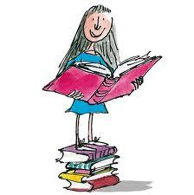

Mathematics

During my time in reception I will have the chance to sort and group objects or materials and explain why I have done this. I will be able to play with lots of resources indoors and outdoors and make comparisons in things like height, weight, size and texture. I will be able to use words like under, on top, between and in front to tell where things are and to put things in order when I play. I will have opportunities to build and make things with shapes and talk about what these shapes look like.

I will be able to use numbers when I play to count and match things to each other. I will begin to learn about adding things together or taking them away. I will learn to recognise numbers all around me and use them confidently in play and games. I will start to be able to put events in order and think about what happens next during the day. I will get the chance to notice patterns in lots of situations and have a go at making patterns myself. I will get to use all I know about maths to solve practical problems when doubling, halving and sharing.

Understanding the world

Having plenty of time indoors and out I will be able to look at and talk about objects, materials, living creatures and plant life, noticing lots of details and things that are the same or different. I will be able to take part in explorations and investigations at all different times of the year in the classroom and in the outdoor environment giving me the chance to notice changes as time passes.

I will have the chance to make predictions, try things out and come to some conclusions and even give some reasons as to why I think things happen. I can share these discoveries with friends and sometimes I will record what I see and find out by drawing, writing or using a camera or computer.

I will be able to talk about special moments and events I have shared with my family and things I am looking forward to. I will begin to know more about different people and their cultures, traditions and places in my community.

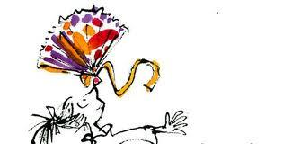

Expressive Arts and Design

I will have the opportunity to express my own thoughts, ideas and feelings through drawing, painting, model making and by using clay. I will use lots of tools to see how they work and what they can do and will use natural and manmade materials to design and make my own creations, models and structures.

I will be able to explore colours, shapes and textures of flat and solid shapes using all of my senses. I will get the opportunity to see interesting objects, pictures and people, feel different moods, taste a variety of flavours, smell an assortment of things and hold or touch things to see how they feel.

I will be able to listen to and make my own music, dance, sing songs and take part in imaginative role play with my friends. It will be nice to find the right means of expression and choose the words to share these times with my friends, my teachers and my family as I play and explore the world around me.

