Characteristics of Effective Learning in Early Years Foundation Stage

Meet our ‘Achievosaurs’

What are the Achievosaurs?
There are seven Achievosaurs altogether, each linking to an aspect of the characteristics of effective learning: Playing and Exploring. Active Learning and Thinking creatively and Critically

They enable children to become more aware of how they learn, and give them language to explain the skills they use when learning. In Class 1, we are beginning to think about ways we could be a good ‘Achievosaur’; for example if a child lets his friend have a turn on the bikes he is being a great ‘Shareosaurus’ or if a child perseveres to write their name, even though it is tricky, they are a super ‘Tryatops’. Each day we will ask the children what kind of dinosaur they have been to encourage the children to think about the ways they learn.

Here are all the Achievosaurs:

“I am EXPLOROSAUR, I explore everything around me.”

“I am ASKARAPTOR, I ask questions and find things out.”
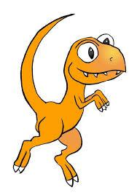
“I am TRYATOPS, I try my best and never give up.”

“I am STICKOSAURAUS, I stick at tasks and persevere.”

“I am SOLVEOSAURUS REX, I work hard to solve problems.”

“I am THINKODOCUS, I think carefully about what I learn.”

“I am SHAREOSAURUS; I share my ideas and resources.”

